700. Search in a Binary Search Tree

Easy

5.3K

171

Companies

You are given the root of a binary search tree (BST) and an integer val.

Find the node in the BST that the node's value equals val and return the subtree rooted with that node. If such a node does not exist, return null.

**Example 1:**

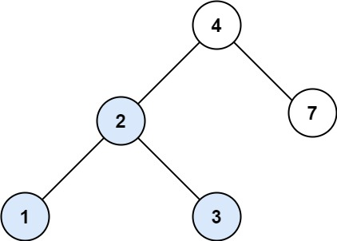

**Input:** root = [4,2,7,1,3], val = 2

**Output:** [2,1,3]

**Example 2:**

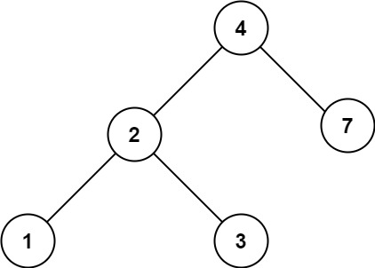

**Input:** root = [4,2,7,1,3], val = 5

**Output:** []

**Constraints:**

* The number of nodes in the tree is in the range [1, 5000].
* 1 <= Node.val <= 107
* root is a binary search tree.
* 1 <= val <= 107